THE CHURCH OF ENGLAND – BIRMINGHAM | SAFEGUARDING |  | 1
Parish Responding to Concerns and Allegations
Procedure

Parish of St Margaret, Olton

agreed by the Parochial Church Council on 22nd July 2026


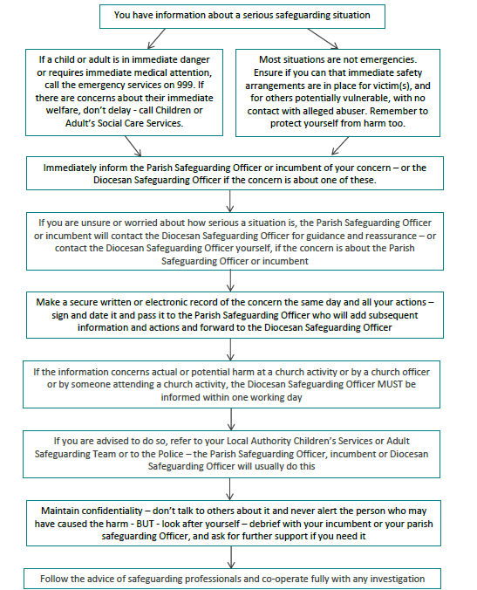

THE CHURCH OF ENGLAND – BIRMINGHAM | SAFEGUARDING |  | 2

LOCAL CONTACT DETAILS
Parish Safeguarding Co-ordinator:  Vicar:  Diocesan Safeguarding Officer:  Police:  Local Authority Children’s Services:  Local Authority Adult Services: | Martin Pyne 07305 113882  Reverend Louise Beasley 0121 706 2318  07342 993 844  999 (emergency) or 101 (non-emergency)  0121 788 4300 out of hours 0121 605 6060  0121 704 8007 out of hours 0121 605 6060

